## **ANALYSIS**

## **Use Case Diagram**

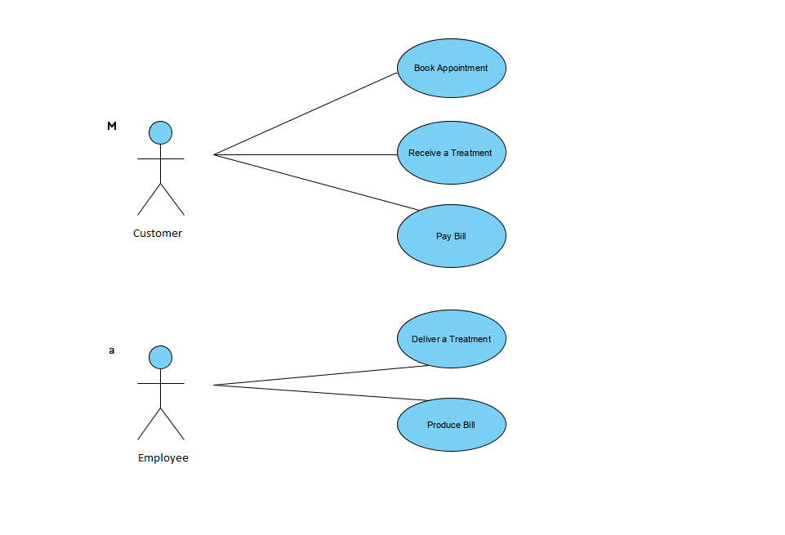

|  |  |
| --- | --- |
| Template for Use Case Description | |
| **Use Case:** | Book Appointment |
| **Actor (s):** | Customer |
| **Goal:** | To Book an Appointment |
| **Overview:**  **Preconditions:**  **Postconditions:** | This use case describes the event of booking appointment via interactive MonaLisa Beauty Web Application. A customer may reserve a specific Treatment with specific Beautician for a specific time period, if available.  Reservation was recorded in the system. |
| **Successful Scenario:** | 1. This use case begins when customer submits Booking request using MonaLisa Beauty Web Application. 2. Customer selecting date and time of the appointment. 3. Next step is to select particular Service. 4. Customer selects particular Beautician. 5. Customer populates their details: Name, Sure Name, Phone Number, Email Address. 6. Customer submits their Booking request. 7. The System lookups for appointment availability. 8. The System saves Booking details in the records. 9. System confirms customer about booking details by redirecting to confirmation website. 10. Customer can book another appointment. |
| **Alternative Scenario (s)** | 7. If booking date/time/beautician is unavailable system informs customer and goes to step 2. |

|  |  |
| --- | --- |
|  | Template for Use Case Description |
| **Use Case:** | Pay Bill |
| **Actor (s):** | Customer |
| **Goal:** | To accept a credit card payment |
| **Overview:**  **Preconditions:**  **Postconditions:** | This use case describes the event of paying bill. Customer pay by credit card, the system sends an authorization request to the credit card authorization system. When approved, a receipt is sent to the guest.  Bill has to be delivered to the customer.  Payment was recorded in the system. |
| **Successful Scenario:** | 1. This use case begins when a customer is ready to pay bill. 2. Contract number, amount, credit card number, expiration month and year is entered. 3. The system sends the credit card number, expiration month, expiration year, amount, and merchant number to the credit card authorization system. When an authorization number is received, records the payment and generates a receipt***.*** 4. Customer receives their receipt. |
| **Alternative Scenario (s)** | 2. If credit card is not authorized, system gives three another attempts. If that fails customer needs to go to front desk. |

|  |  |
| --- | --- |
| Template for Use Case Description | |
| **Use Case:** | Receive a Treatment |
| **Actor (s):** | Customer |
| **Goal:** | To Receive a Treatment |
| **Overview:**  **Preconditions:**  **Postconditions:** | This use case describes the event of receiving treatment booked via interactive MonaLisa Beauty Web Application. In order to receive a treatment customer needs to provide particular details: ID with Name and Surname, Date and Time of the treatment, email address or phone number.  Name and Surname, phone number or email address need to be confirmed in the system. |
| **Successful Scenario:** | 1. This use case begins when customer arrives at MonaLisa Beauty front desk. 2. Customers gives their Name and Surname, confirms email address or phone number. 3. Booking details need to be confirmed in the system at the arrival time. 4. Customer is given treatment consent form. 5. Customer provides: their personal details, medical history. 6. Booking of the treatment is confirmed. 7. Customer receives the treatment. |
| **Alternative Scenario (s)** | 2. If customer doesn't have appointment, execute **Book Appointment** use case one. |

|  |  |
| --- | --- |
| Template for Use Case Description | |
| **Use Case:** | Deliver a Treatment |
| **Actor (s):** | Employee |
| **Goal:** | To Deliver Treatment |
| **Overview:**  **Preconditions:**  **Postconditions:** | This use case describes the event of delivering treatment booked via interactive MonaLisa Beauty Web Application. In order to fully deliver a treatment employee needs to check and update type of the treatment in the records.  Treatment needs to be delivered.  Type of the treatment needs to be checked on the system and updated if needed. |
| **Successful Scenario:** | 1. This use case begins when employee finishing delivering treatment to the customer. 2. This use case begins when and finishing delivering treatment to the customer. 3. Employee checks for customer in the system and confirms treatment. 4. System update the records. |
| **Alternative Scenario (s)** | 3. If treatment details are incorrect employee populates correct one. |

|  |  |
| --- | --- |
|  | Template for Use Case Description |
| **Use Case:** | Produce Bill(external payment system) |
| **Actor (s):** | Employee |
| **Goal:** | To produce a bill. |
| **Overview:**  **Preconditions:**  **Postconditions:** | This use case describes the event of producing a bill. When customer received booked treatment. Employee confirms in the system provide treatment to the customer. The System updating records.    Customer must receive treatment.  Final bill must be delivered to the customer. |
| **Successful Scenario:** | 1. This use case begins treatment is delivered to the customer. 2. Employee checks treatment in the system. 3. System confirms fees on the bill. 4. Final bill is delivered to the customer. |
| **Alternative Scenario (s)** |  |

## Class Diagram

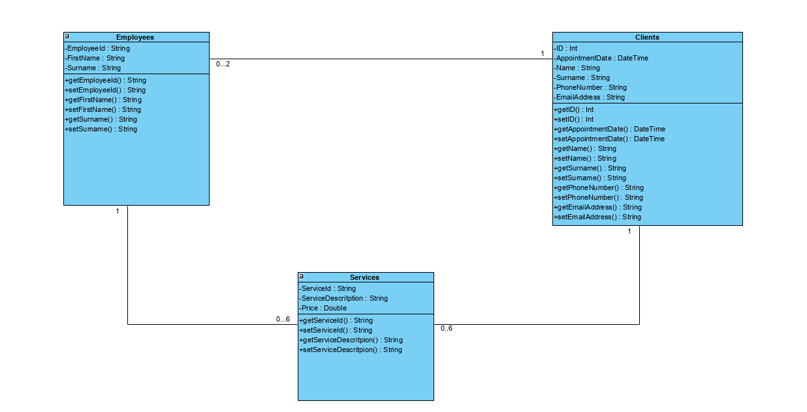 Object Oriented Relationship - Association